

To: Professor Alan Pisano

From: Jessica Cadreau, Jennifer Fong, Cameron Graves, Makenna Hart, Steven Li

Team: Sweet Grid: Team 20

Date: 2/17/17

Subject: The SWEET City Second Deliverable Test Report

1. **Project Objective**
   1. The overall objective of the SWEET Grid Energy Efficiency Module is to inform National Grid customers of the power consumption differences between LEDs and incandescent lights in an interactive manner. The module allows them to toggle between LED and incandescent light bulbs by pressing push button switches. The power consumption differences will show National Grid customers the major benefits of using LED lighting in their homes.
   2. This module will display the power consumed by each light bulb and will later be scaled to a realistic value for use in a city. A possible add on to emphasize the power saved by using LEDs is a model MBTA Green Line train that runs on the excess power not used by the LED.

**2.0 Test Objective and Significance**

2.1 The circuit setup for the energy efficiency module is shown in figure 1. The test procedure focuses on the switching nature of transistors. Using both p and n type transistors, the circuit is able to toggle between two separate visual loads. The circuit is described with more detail in section 3.

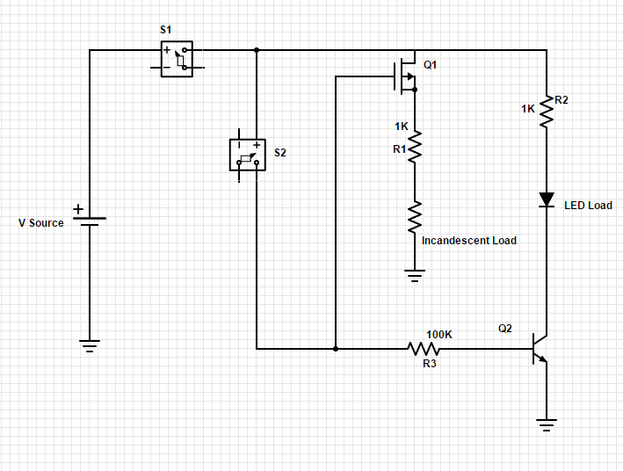



2.2 This deliverable is essential not only because is it one fourth of the total project, but we can also expand the circuit to potential add ons for the final product. This particular deliverable is the first to utilize the LCD displays. The display code and hardware can be applied to all four modules of the project, which completes another project requirement.

2.3 **Energy Efficiency Module**

2.3.1 The objective in testing the energy efficiency module is to show completion of one fourth of the project. The energy efficiency circuitry can potentially apply to the more complicated circuitry of the Smart Grid module. This circuit has more Smart Grid applicable elements than the previous solar and wind modules. Additionally, having the circuit work successfully on a breadboard allows the team to move forward with the printed circuit board required in the final product.

2.4 **Simulation and Display**

2.4.1 The objective of testing the simulation and display is to understand the basics for programming the circuit to do specific actions and displaying data. Each module requires specific data to be displayed. The energy efficiency display is very similar to the over three modules. Displaying the power consumption for this module is helpful for other module data displays.

**3.0 Equipment and Setup**

3.1 **Overall Arrangement - Energy Efficiency Module**

3.1.1 Figures 2, 3, and 4 show the three modes of circuit: both loads off, incandescent bulb lit, and LED lit, respectively. The circuit utilizes two push button switches, a P type mosfet, and an NPN BJT to power the two loads.

The first switch, S1, is a universal on off switch. When S1 is pressed, the voltage source is connected to the rest of the circuit. With S2 off, the gate of the P type mosfet (Q1) is off. This turns the mosfet on and the incandescent load is lit. When S2 is pressed, the gate of Q1 goes high, shutting off the mosfet and the incandescent load. At the same time, a base voltage is applied to Q2, turning on the NPN transistor. This lights the LED load. If S2 is released, the circuit switches back to the incandescent load. If S1 is opened at any time, the entire circuit shuts off.

Also included in the module design is a Raspberry Pi 3 and an LCD screen. When the push button switches are pushed, a voltage is also applied to a pin of the Raspberry Pi. Depending on the pin input, the the Raspberry Pi will display either incandescent or LED power consumption on the LCD. If neither button is pressed, the display shows a power consumption of zero watts.

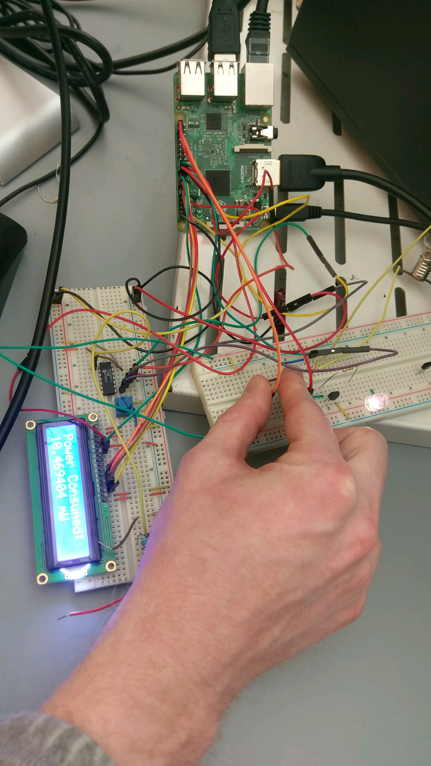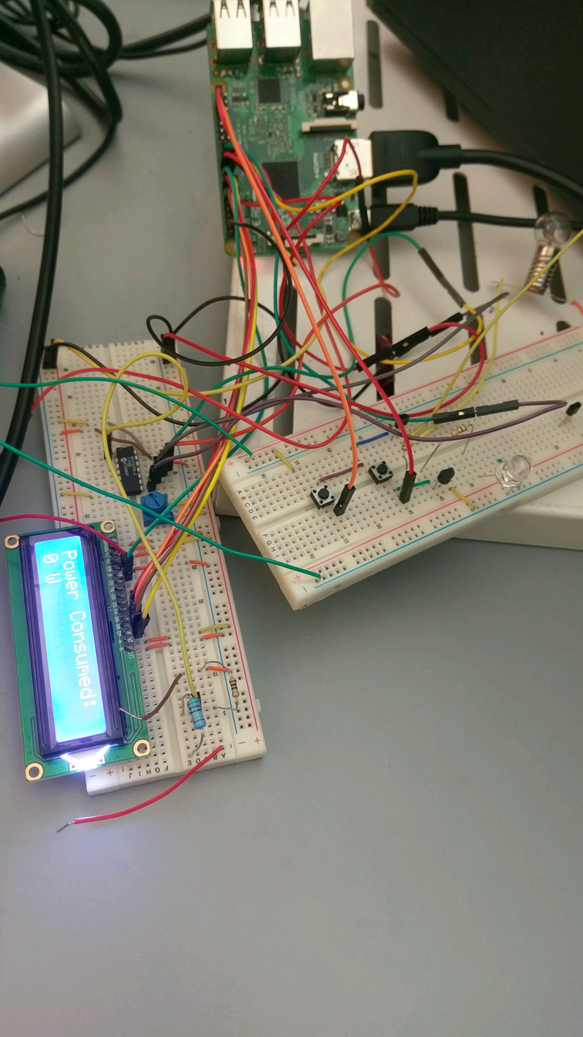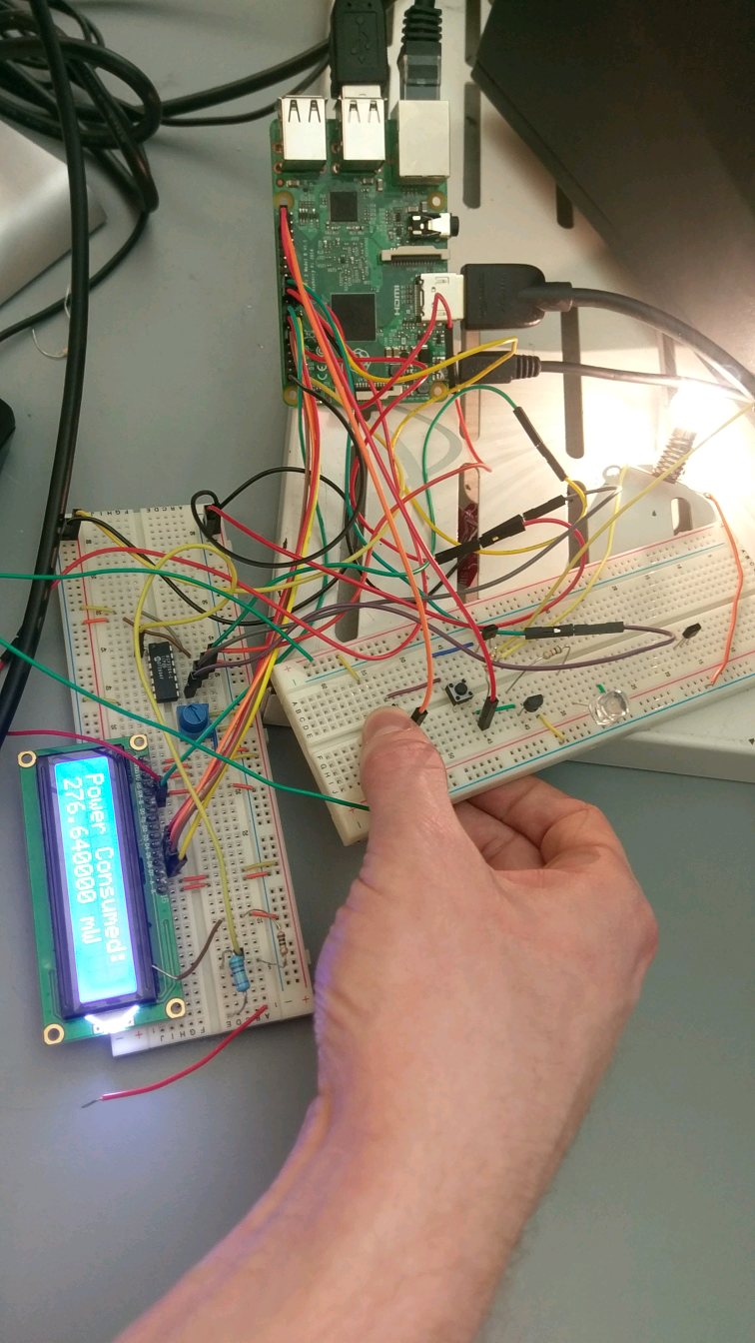

3.2 **Simulation and Display**

3.2.1 There are multiple components needed for this module to function appropriately. An LCD screen is used as the main display of power consumption. To set this up, the screen is connected to a breadboard. The necessary pins from the LCD are connected to the corresponding pins on the Raspberry Pi. With the LCD setup, the GPIO pins of the Pi are used to check which push buttons are being pressed. This is done with the help of some GPIO setup inside the python code which is the last necessary component. In the code there are sections that prepare the LCD displays as well as turns the specified GPIO pins as input pins. A section is created for the variables that will contain the voltages, currents, and the power values for the two possible outcomes of our circuit. Finally, a loop is used that will continuously send the values to the LCD depending on which input pins are triggered. This loop will wait for a specified delay period before clearing the display and show a new message.

**4.0 Measurements and Data**

4.1 **Energy Efficiency Module**

4.1.1 The energy efficiency data includes brightnesses of each visual load and power consumption differences. Using an 8V source, at equal brightnesses, the LED consumed 26 times less power than the incandescent bulb. (P Led = 10.47mW, P incandescent = 276.6 mW.) Unfortunately, the incandescent bulb drew ~200 mA of current, which is outside our safety specifications. The current can be limited by changing resistor values, but this will also change the brightness of the bulb.

4.2 **Simulation and Display**

4.2.1 For testing the simulation and display, the data that was collected was whether or not the correct value was displayed based on which push button was pressed. If the universal on-off switch was pressed, the LCD would display the previously calculated power consumption of the incandescent light bulb. If both the universal switch and the second button was pressed, the LCD would display the previously calculated power consumption of the LED. When neither button is pressed the LCD would display that no power was being consumed.

**5.0 Conclusions**

5.1 **Energy Efficiency Module**

5.1.1 For the energy efficiency module, success is measured in terms of the correct light bulbs turning on when the corresponding buttons are pressed.

The circuit testing was deemed successful because:

* Incandescent bulb was lit and LED was not lit when switch 1 was pressed
* LED was lit and incandescent was not when switches 1 and 2 were pressed

5.2 **Simulation and Display**

5.2.1 For the simulation and display, the test is successful if the correct calculated value of power consumption is displayed when the corresponding buttons are pressed.

5.3 **Summary and Future Plans**

5.3.1 Overall, the energy efficiency module requires some changes, but was a success. The main issues were the high current values through the incandescent bulb and measurement issues due to the current limiting mode of the power supply. After reducing the current in the incandescent bulb, we will address the low brightness that follows.

5.3.2 To finish this project, PCBs for each modules need to be designed and sent out, the models of Boston landmarks need to finish 3d printing, and the Smart Grid circuit has to be designed. Most of these are in progress, but still need more work.